**2D Structure Prediction and Validation:**

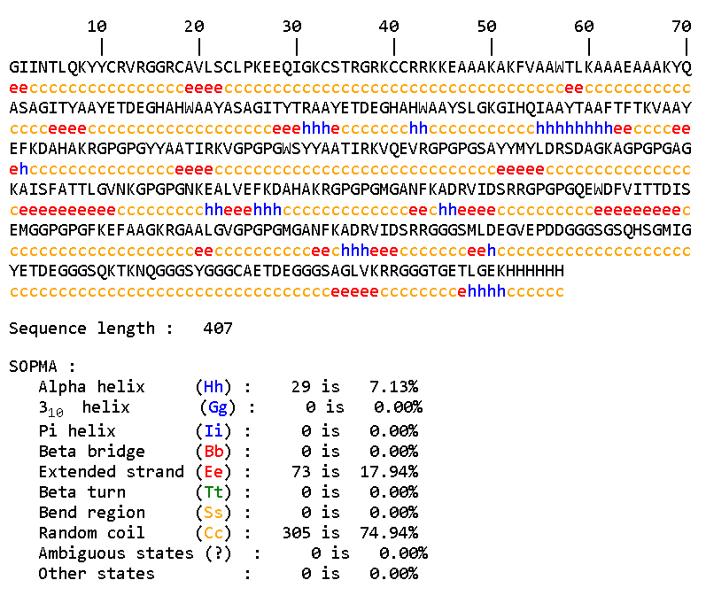

**Secondary Structure Prediction Results of Vaccine construct by SOPMA**

**Physiochemical Properties:**

|  |  |
| --- | --- |
| **PROPERTY** | **VALUE** |
| Number of Amino acids | 407 |
| Molecular weight | 42227.03 Da |
| Theoretical pI | 9.25 |
| Total number of atoms | 5820 |
| Extinction coefficients | **57675** |
| Instability index | 24.68 |
| Aliphatic index | 50.81 |
| Grand average of hydropathicity | -0.591 |
| Estimated half-life (mammalian reticulocytes, in vitro) | 30 hours |

